INDEX

SR | PRACTICALS | DATE | SIGN
1 | To install Selenium IDE in web browser | 18/07/2026
2 | To test demo website in Selenium IDE | 18/07/2026
3 | To test login demo website in Selenium IDE | 18/07/2026
4 | To create a test suite containing a minimum of 4 test cases to validate different web page formats (HTML page, XML response, JSON API output, and a dynamic form page), execute the test suite, and generate the report | 25/07/2026
5 | To perform cross-website functional testing using selenium ide procedure | 30/07/2026
6 | To Prepare Test Plan, Test Scenarios, Test Cases and Execute Test Cases Manually and prepare Test Execution Report and Defect Report as per STLC process. | 22/08/2026
7 | To perform Selenium Server (Grid) Configuration and Remote Execution | 12/09/2026
8 | To perform automation script of login on specified URL using login assertions | 26/09/2026
9 | To perform Web Element Interaction and Synchronization Handling | 26/09/2026
10 | Design and execute load testing scenarios for web applications and analyse response time. | 07/10/2026

Practical 6

Aim: To Prepare Test Plan, Test Scenarios, Test Cases and Execute Test Cases Manually and prepare Test Execution Report and Defect Report as per STLC process.
Pre-requisites: Operating System: Windows 11, Browser: Google Chrome, Testing Method: Black Box Testing, Testing Type: Manual Functional Testing
Application: OrangeHRM Web Application

PROCEDURE:

Open Selenium IDE:
  - Open Chrome.
  - Launch the Selenium IDE extension.
  - Create a new project/test case.
  - Give the test an appropriate name, e.g. OrangeHRM_Login.

Test Case TC-001 — Verify Login Page
Record/execute the steps:
- open → OrangeHRM URL: https://opensource-demo.orangehrmlive.com/web/index.php/auth/login
- Verify Username field, password field, Login button, Forgot Password link
- assert Text/assert Title
Expected output: Login page should be displayed
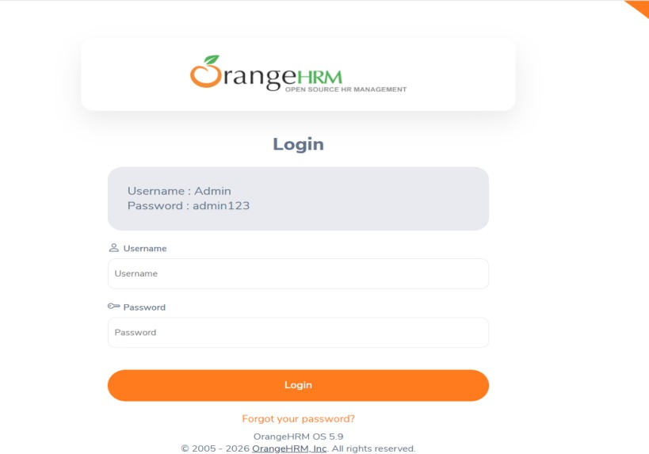
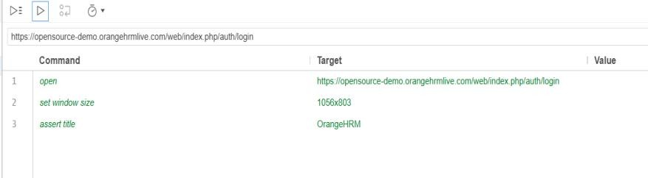

TC-002 — Valid Login
Add Selenium IDE commands corresponding to:
- Open application.
- Enter username → Admin
- Enter password → admin123
- Click Login.
Expected output: Dashboard should be displayed.
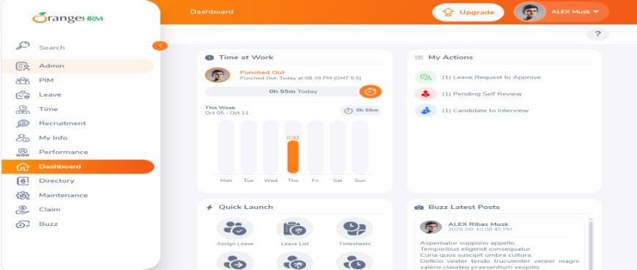
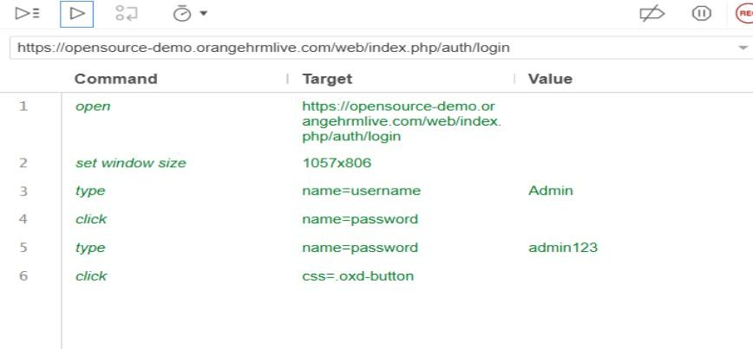

TC-003 — Invalid Username
Commands:
- Open application.
- Enter username → WrongUser
- Enter password → admin123
- Click Login.
- Verify the error message.
Expected: Login should fail and an appropriate error message should appear.
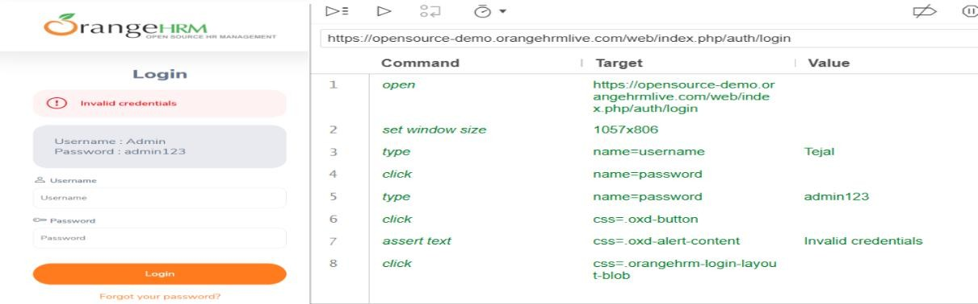

TC-003 — Invalid Username
- Open application.
- Enter username → Admin
- Enter password → wrongpassword
- Click Login.
- Verify the error message.
Expected: Login should fail and an appropriate error message should appear.
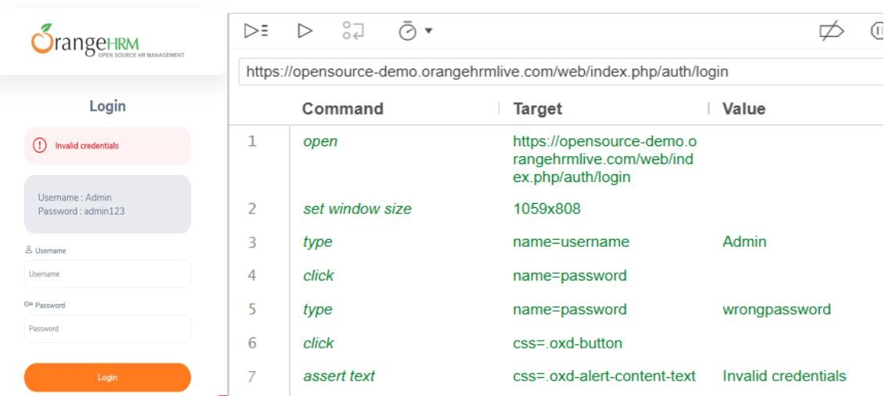

TC-005 — Blank Username
Commands:
- Open application.

Leave Username blank.
- Enter Password → admin123
- Click Login.
- Check username validation.
Expected: Username validation/required message should appear.
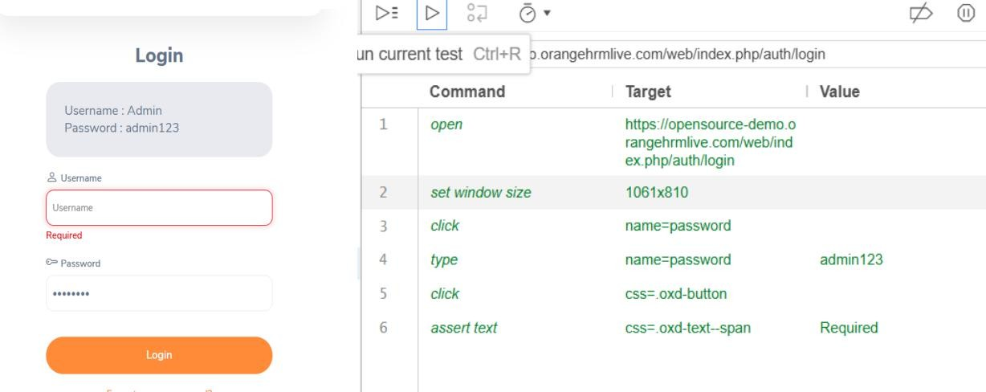

TC-006 — Blank Password:
- Open application.
- Username → Admin

Leave Password blank.

- Click Login.
- Verify password validation.
Expected: Password validation/required message should appear.
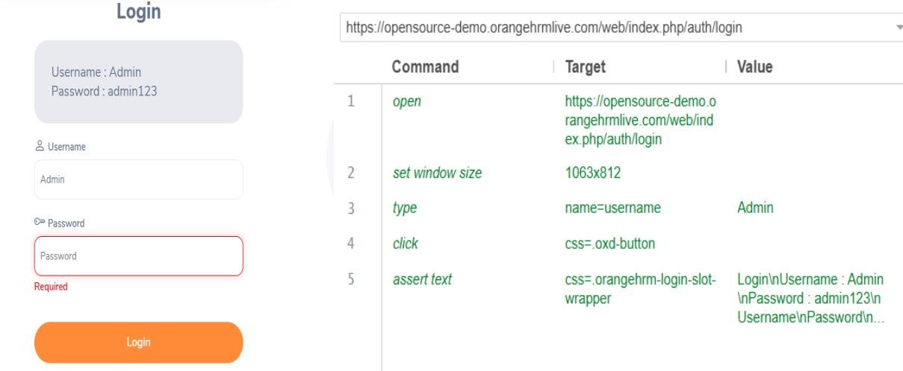

TC-007 — Both Fields Blank
- Open application.

Leave Username blank.
- Leave Password blank.
- Click Login.
- Verify validation messages.
Expected: Validation messages for both Username and Password.
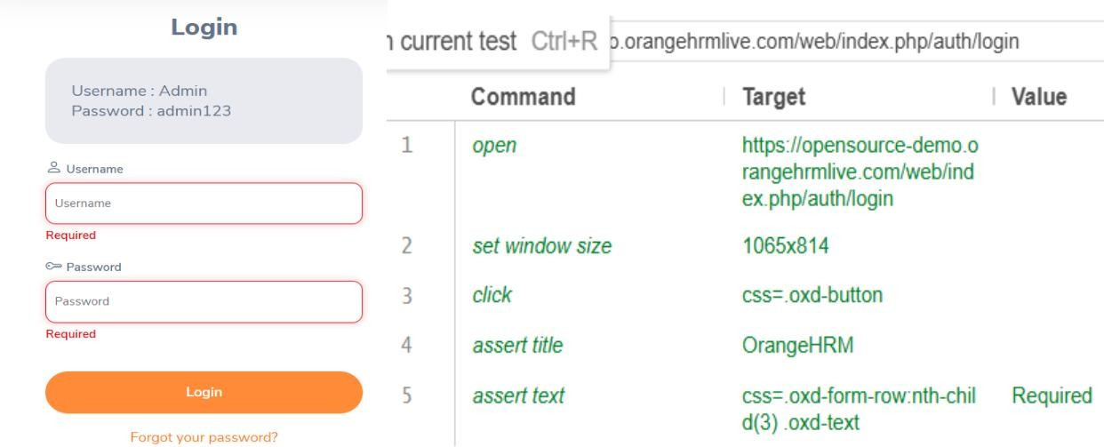

TC-008 — Password Masking
- Open application.
- Click Password field.
- Type admin123.
- Verify that the password is masked.

Expected: Password should appear as dots/asterisks.
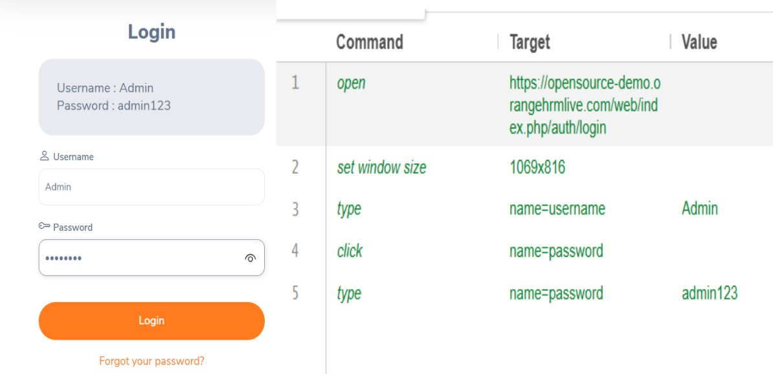

TC-009 — Forgot Password
- Open application.
- Click Forgot Password.
- Verify that the password recovery page opens. Expected: Password recovery page should be displayed.
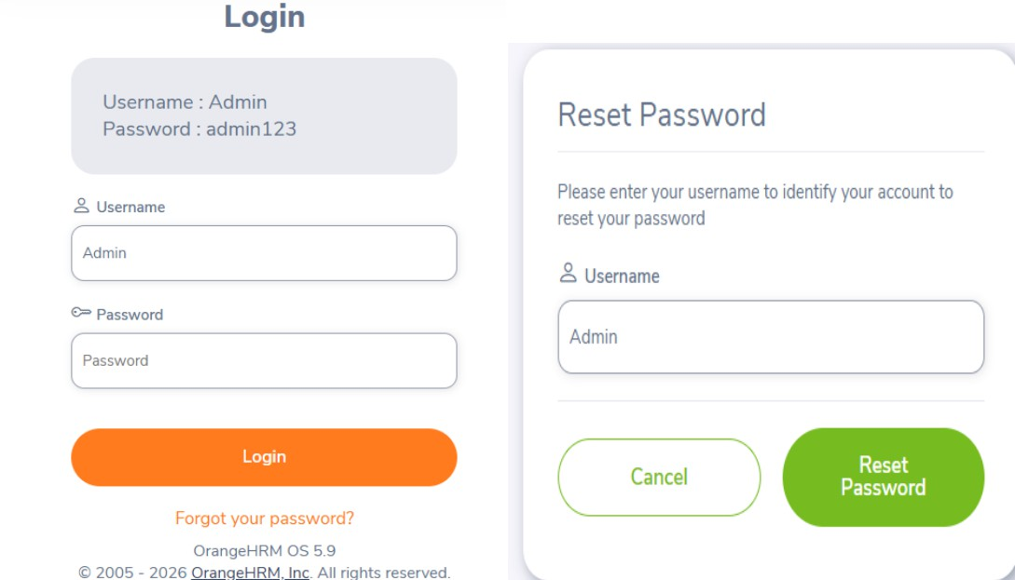

CONCLUSION:
The testing activity has been successfully completed.

Final Result
Finally, prepare the closure: Total Test Cases: 9 Executed: 9
Passed after retesting: 9 Open Failed: 0
Testing Status: Completed.

Practical 7

Aim: Selenium Server (Grid) Configuration and Remote Execution

Step 1:-Install java
Check for version in command promt Cmd java –version
Cmd javac –version

Step 2:-Install Selenium grid server latest version
Download Selenium ServerGo to the official Selenium website:Selenium Downloads
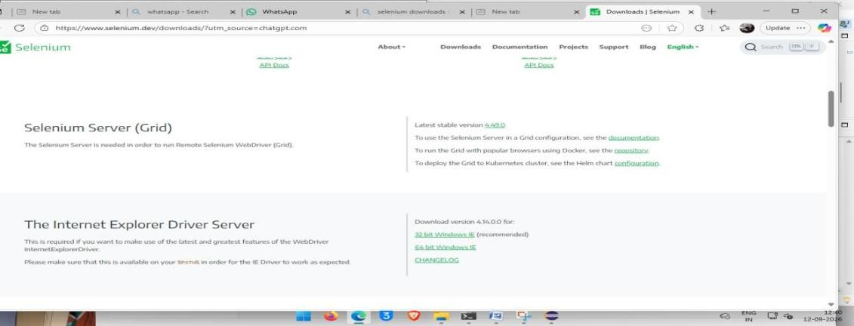
Find Selenium Server and download the .jar file. For example:
selenium-server-4.x.x.jar

Step 3: Create Selenium folder in C drive
Create:
C:\Selenium
Put the downloaded .jar file inside it.
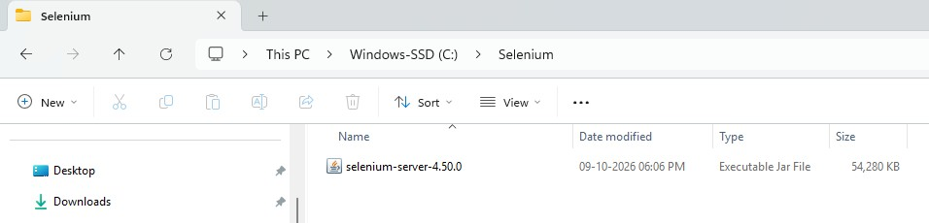
For example:
C:\Selenium\selenium-server-4.x.x.jar

folder should look like:
C:
└── Selenium
└── selenium-server-4.x.x.jar
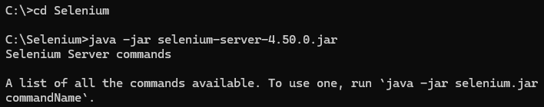

Step 4:-Start Selenium hub
Go to cmd and move to Selenium directory
Type java -jar selenium-server-4.x.x.jar hub(give proper version)
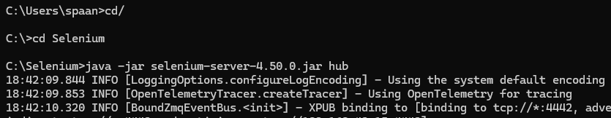
Selenium Grid hub opens

Step 5:-
Open Chrome or Edge.Go to:http://localhost:4444 We should see the Selenium Grid page.
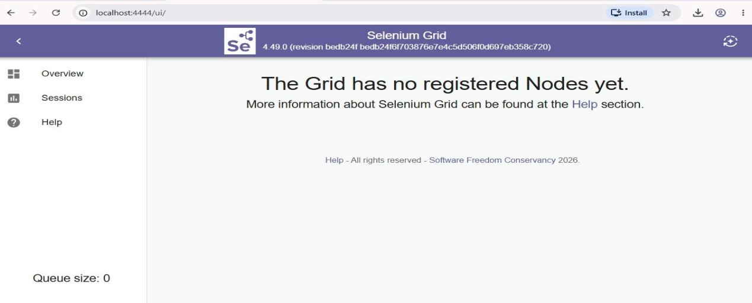

Step 6:-Start a node
Open other cmd go to selenium folder Type the following command

java -jar selenium-server-4.x.x.jar node --hub http://localhost:4444(give proper version)
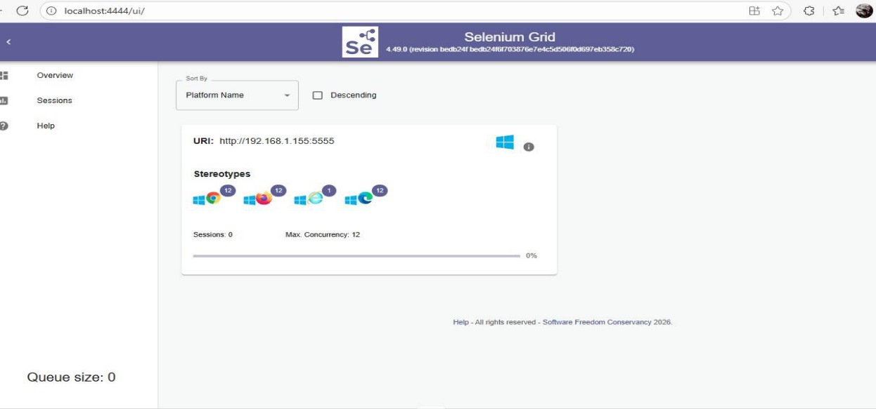

Step 7:- open grid console
Verify whether all browsers are registered or not

Step 8 Create Maven Project in Eclipse Step 8: Open Eclipse
Open Eclipse. Select:
File
↓
New
↓
Maven Project
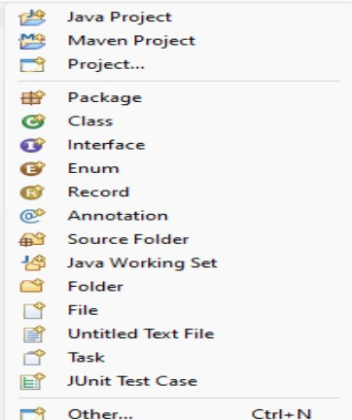

Step 9: Select Maven project option
You will see:

Create a simple project (skip archetype selection)Check it. Click:Next

Step 10 — Fill Maven Project Details Step 10: Enter project information Fill:
Group Id:com.selenium.grid Artifact Id:SeleniumGridDemo
Version:
0.0.1-SNAPSHOT
Packaging:
Jar
We can leave the version as the default.Click:Finish
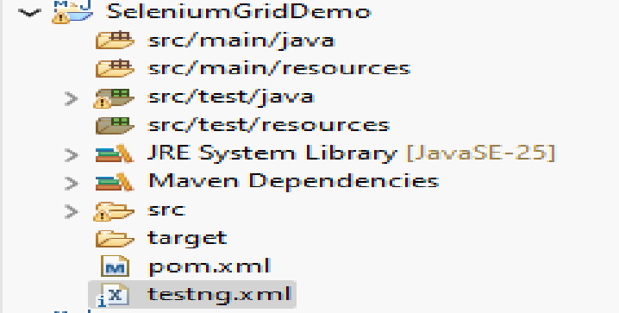

Step 11 — Configure pom.xml Step 11: Open pom.xml
In Eclipse:
SeleniumGridDemo
└── pom.xml
Open it.Add Selenium and TestNG dependencies inside <dependencies>.

<project xmlns="http://maven.apache.org/POM/4.0.0" xmlns:xsi="http://www.w3.org/2001/XMLSchema-instance" xsi:schemaLocation="http://maven.apache.org/POM/4.0.0
https://maven.apache.org/xsd/maven-4.0.0.xsd">
<modelVersion>4.0.0</modelVersion>
<groupId>com.selenium.grid</groupId>
<artifactId>SeleniumGridDemo</artifactId>
<version>0.0.1-SNAPSHOT</version>

<dependencies>

<!-- Selenium WebDriver -->
<dependency>
<groupId>org.seleniumhq.selenium</groupId>
<artifactId>selenium-java</artifactId>
<version>4.34.0</version>
</dependency>

<!-- TestNG -->
<dependency>
<groupId>org.testng</groupId>
<artifactId>testng</artifactId>
<version>7.11.0</version>
<scope>test</scope>
</dependency>

</dependencies>

</project> Save the file

Step 12 — Update Maven Project Step 12: Update dependencies
Right-click the project:SeleniumGridDemo
Select:Maven
↓
Update Project
Click:OK
Wait for Eclipse to download the dependencies

Step 13 — Create Package Step 13: Create Java package
Go to:src/test/javaRight-click:
New
↓
Package Enter:com.selenium.gridClick Finish.

Step 14 — Create Test Class Step 14: Create Java class
Right-click:com.selenium.grid AND Select:
New
↓
Class Enter:GridCrossBrowserTest Click Finish.

Step 15 — Write RemoteWebDriver Code Step 15: Add imports
packagecom.selenium.grid; importjava.net.URI;
import java.net.URL; importorg.openqa.selenium.By; importorg.openqa.selenium.WebDriver; importorg.openqa.selenium.chrome.ChromeOptions; importorg.openqa.selenium.firefox.FirefoxOptions;
importorg.openqa.selenium.remote.RemoteWebDriver; importorg.testng.Assert; importorg.testng.annotations.AfterMethod; importorg.testng.annotations.BeforeMethod; importorg.testng.annotations.Parameters; importorg.testng.annotations.Test; publicclassGridCrossBrowserTest {
WebDriver driver;

@BeforeMethod @Parameters("browser")
publicvoidsetup(String browser) throws Exception {
URL gridUrl = URI.create("http://localhost:4444").toURL(); if (browser.equalsIgnoreCase("chrome")) {
ChromeOptions options = newChromeOptions();

driver = newRemoteWebDriver( gridUrl,
options
);
} elseif (browser.equalsIgnoreCase("firefox")) {

FirefoxOptions options = newFirefoxOptions();

driver = newRemoteWebDriver( gridUrl,
options
);
}
driver.manage().window().maximize();
}
@Test publicvoidgoogleTest() {
driver.get("https://www.google.com/"); String title = driver.getTitle();
System.out.println(
"Browser = "
+ ((RemoteWebDriver) driver)
.getCapabilities()
.getBrowserName()
);
System.out.println(
"Page Title = " + title
);
Assert.assertTrue( title.toLowerCase().contains("google")
);
}
@AfterMethod publicvoidtearDown() {

if (driver != null) { driver.quit();
}
}
}

Step 16 Create testing.xml file
In Eclipse, right-click your project:SeleniumGridDemo AND Choose: New
→ File
Name the file:testng.xml Click Finish.

Code:-
<?xml version="1.0" encoding="UTF-8"?>
<suite name="Cross Browser Suite" parallel="tests"
thread-count="2">

<test name="Chrome Test">
<parameter name="browser" value="chrome"/>
<classes>
<class name="com.selenium.grid.GridCrossBrowserTest"/>
</classes>
</test>

<test name="Firefox Test">

<parameter name="browser" value="firefox"/>

<classes>
<class name="com.selenium.grid.GridCrossBrowserTest"/>
</classes>

</test>

</suite>
Click save
Start hub and node again

Step 17 — Run the TestNG suite
In EclipseRight-click:testng.xmlThen:
Run As
→ TestNG Suite
TestNG should start:
Chrome Test
+
Firefox Test
Your browser windows should open through Selenium Grid.

Step 18 — Expected Console Output
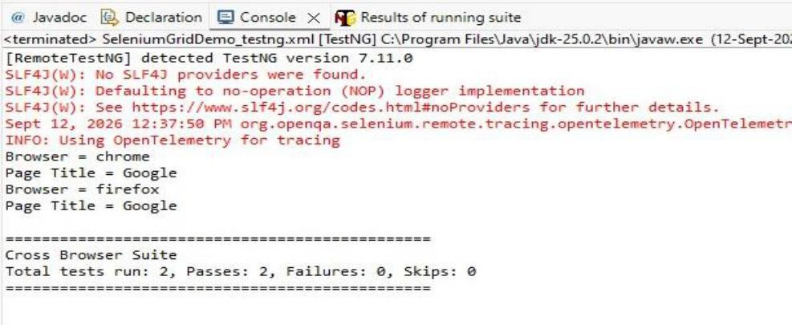

Practical 8

Aim: To perform automation script of login on specified URL using login assertions

- Objective
Automate the login process of a web application and verify that login is successful using:
  - Username and password entry
  - Login button click
  - URL validation
  - Welcome message validation
  - Logout button visibility validation
  - Logout after successful login

Software Required
Install:
- Java JDK 17 or later
- Eclipse IDE
- Maven
- Google Chrome
- Selenium WebDriver
- TestNG

You do not normally need to manually download ChromeDriver with recent Selenium versions because Selenium Manager can automatically manage the browser driver.

Create Maven Project
Open Eclipse.

Step 1
Go to:
File → New → Maven Project

Step 2
Select:

Create a simple project (skip archetype selection)
Click Next.

Step 3 – Fill Maven Project Details
Use:

Field | Value
Group Id | com.demo
Artifact Id | LoginAutomation
Version | 0.0.1-SNAPSHOT
Packaging | jar

Click Finish.

Project Structure
Your project should look approximately like this: LoginAutomation
├── src/main/java
├── src/test/java
│ └── com.demo.login
│ └── LoginTest.java
├── pom.xml
└── JRE System Library
We will put our TestNG test class inside: src/test/java

Add Selenium and TestNG Dependencies
Open:
Copy pom.xml code
<?xml version="1.0" encoding="UTF-8"?>

<project xmlns="http://maven.apache.org/POM/4.0.0" xmlns:xsi="http://www.w3.org/2001/XMLSchema-instance" xsi:schemaLocation="http://maven.apache.org/POM/4.0.0
https://maven.apache.org/xsd/maven-4.0.0.xsd">

<modelVersion>4.0.0</modelVersion>

<groupId>com.example</groupId>
<artifactId>LoginAutomation</artifactId>
<version>0.0.1-SNAPSHOT</version>

<dependencies>

<dependency>
<groupId>org.seleniumhq.selenium</groupId>
<artifactId>selenium-java</artifactId>
<version>4.34.0</version>
</dependency>

<dependency>
<groupId>org.testng</groupId>
<artifactId>testng</artifactId>
<version>7.11.0</version>
<scope>test</scope>
</dependency>

</dependencies>

</project>
Save the file.
Maven should download the required Selenium and TestNG libraries.

Create TestNG Class
Right-click:
src/test/java Select:
New → Package
Enter:
com.demo.login
Then right-click the package:
New → Class
Class name:
LoginTest Click Finish.

Complete Login Automation Code
Copy java class code: package com.demo.login; import java.time.Duration; import org.openqa.selenium.By;
import org.openqa.selenium.WebDriver; import org.openqa.selenium.WebElement;
import org.openqa.selenium.chrome.ChromeDriver;
import org.openqa.selenium.support.ui.ExpectedConditions; import org.openqa.selenium.support.ui.WebDriverWait; import org.testng.Assert;
import org.testng.annotations.AfterMethod;

import org.testng.annotations.BeforeMethod; import org.testng.annotations.Test;
public class LoginTest { WebDriver driver;
WebDriverWait wait;
// Method to pause the browser public void pause() {
try { Thread.sleep(3000);
} catch (InterruptedException e) { Thread.currentThread().interrupt();
}
}
@BeforeMethod public void setUp() {
System.out.println("Starting browser..."); driver = new ChromeDriver();
driver.manage().window().maximize(); pause();
System.out.println("Opening OrangeHRM..."); driver.get("https://opensource-demo.orangehrmlive.com/");
wait = new WebDriverWait(driver, Duration.ofSeconds(15)); pause();
System.out.println("Login page opened.");
}
@Test
public void loginValidation() {
// STEP 1 - Username System.out.println("STEP 1: Entering username..."); WebElement username = wait.until( ExpectedConditions.visibilityOfElementLocated(
By.name("username")
)
);
username.sendKeys("Admin"); System.out.println("Username entered: Admin"); pause();
// STEP 2 - Password System.out.println("STEP 2: Entering password..."); WebElement password = wait.until( ExpectedConditions.visibilityOfElementLocated(
By.name("password")
)
);
password.sendKeys("admin123"); System.out.println("Password entered."); pause();
// STEP 3 - Login
System.out.println("STEP 3: Clicking Login button..."); WebElementloginButton = wait.until(

ExpectedConditions.elementToBeClickable( By.xpath("//button[@type='submit']")
)
);
loginButton.click(); System.out.println("Login button clicked."); pause();
// STEP 4 - Dashboard
System.out.println("STEP 4: Waiting for Dashboard..."); wait.until( ExpectedConditions.urlContains("/dashboard")
);
System.out.println("Dashboard loaded."); pause();
// STEP 5 - URL validation
System.out.println("STEP 5: Checking Dashboard URL..."); String actualURL = driver.getCurrentUrl();
System.out.println("Current URL: " + actualURL); Assert.assertTrue( actualURL.contains("/dashboard"),
"Dashboard URL not found."
);
System.out.println("PASS: URL validation successful."); pause();
// STEP 6 - Dashboard text
System.out.println("STEP 6: Checking Dashboard text..."); WebElementdashboardText = wait.until( ExpectedConditions.visibilityOfElementLocated( By.xpath("//h6[text()='Dashboard']")
)
);
Assert.assertTrue( dashboardText.isDisplayed(),
"Dashboard is not displayed."
);
Assert.assertEquals( dashboardText.getText(),
"Dashboard"
);
System.out.println(
"PASS: Dashboard text = "
+ dashboardText.getText()
);
pause();
// STEP 7 - Profile menu System.out.println("STEP 7: Opening profile menu..."); WebElementprofileMenu = wait.until( ExpectedConditions.elementToBeClickable(
By.xpath(
"//span[contains(@class,'oxd-userdropdown-tab')]"

)
)
);
profileMenu.click(); System.out.println("Profile menu opened."); pause();
// STEP 8 - Logout
System.out.println("STEP 8: Checking Logout button..."); WebElementlogoutButton = wait.until( ExpectedConditions.visibilityOfElementLocated( By.xpath("//a[text()='Logout']")
)
);
Assert.assertTrue( logoutButton.isDisplayed(),
"Logout button is not visible."
);
System.out.println("PASS: Logout button is visible."); pause();
// FINAL RESULT
System.out.println(); System.out.println("======================================");
System.out.println(" LOGIN AUTOMATION TEST PASSED"); System.out.println("======================================");
// Keep browser open for another 5 seconds System.out.println("Keeping browser open for 5 seconds...");
try { Thread.sleep(5000);
} catch (InterruptedException e) { Thread.currentThread().interrupt();
}
}
@AfterMethod
public void tearDown() { System.out.println("Closing browser...");
if (driver != null) { driver.quit();
}
System.out.println("Browser closed.");
}
}
Save the file
Run the file as Testng and see the output

Run As → TestNG Test

Expected Console Output
You should see something similar to:
URL Validation Passed
Current URL: https://opensource-demo.orangehrmlive.com/web/index.php/dashboard/index
Dashboard Validation Passed Logout/User Menu Validation Passed Logout option is visible
Logout Successful PASSED: loginTest

Test Cases for Your Practical
You can document the practical using these test cases:

TC ID Test Case | Expected Result
TC01 Open login page | Login page displayed
TC02 Enter valid username | Username entered successfully
TC03 Enter valid password | Password entered successfully
TC04 Click Login | User redirected to dashboard
TC05 Validate URL | Dashboard URL displayed
TC06 Validate welcome/dashboard message | Dashboard displayed

Practical 9

Aim: Web Element Interaction and Synchronization Handling

Prequisites: Selenium WebDriver with Java, Maven and TestNG
Elements covered: Textbox, Radio button, Checkbox, Dropdown, Alert, Frame, Implicit wait, Explicit wait

STEP 1 — Open Eclipse
Open Eclipse Then:File → New → Maven ProjectIf Maven Project is not visible:
File → New → Other → Maven → Maven Project Click Next.

STEP 2 — Select Maven Project
You may see: Create a simple project (skip archetype selection)For an easy setup, check this box. Click Next.

STEP 3 — Enter Maven Details Enter:
Field | Value
Group Id | com.selenium
Artifact Id | SeleniumTest
Version | 0.0.1-SNAPSHOT
Packaging | jar

Then click Finish. Your project should look approximately like:
selenium-test
├── src/main/java
├── src/test/java
├── JRE System Library
├── Maven Dependencies
STEP 4 — Open pom.xmlOpen: Paste code and save and update maven even update main project
<?xml version="1.0" encoding="UTF-8"?>
<project xmlns="http://maven.apache.org/POM/4.0.0" xmlns:xsi="http://www.w3.org/2001/XMLSchema-instance" xsi:schemaLocation="http://maven.apache.org/POM/4.0.0 https://maven.apache.org/xsd/maven-4.0.0.xsd">
<modelVersion>4.0.0</modelVersion>

<groupId>com.selenium</groupId>
<artifactId>WebElementPractical</artifactId>
<version>0.0.1-SNAPSHOT</version>
<properties>
<maven.compiler.source>17</maven.compiler.source>
<maven.compiler.target>17</maven.compiler.target>
<project.build.sourceEncoding>UTF-8</project.build.sourceEncoding>
</properties>
<dependencies>
<!-- Selenium WebDriver -->
<dependency>
<groupId>org.seleniumhq.selenium</groupId>
<artifactId>selenium-java</artifactId>
<version>4.35.0</version>
</dependency>
<!-- TestNG -->
<dependency>
<groupId>org.testng</groupId>
<artifactId>testng</artifactId>
<version>7.11.0</version>
<scope>test</scope>
</dependency>
</dependencies>
<build>
<plugins>
<!-- Maven Compiler Plugin -->
<plugin>
<groupId>org.apache.maven.plugins</groupId>
<artifactId>maven-compiler-plugin</artifactId>
<version>3.13.0</version>
<configuration>
<source>17</source>
<target>17</target>
</configuration>
</plugin>
<!-- Maven Surefire Plugin -->
<plugin>
<groupId>org.apache.maven.plugins</groupId>
<artifactId>maven-surefire-plugin</artifactId>
<version>3.5.0</version>
<configuration>
<suiteXmlFiles>
<suiteXmlFile>testng.xml</suiteXmlFile>
</suiteXmlFiles>
</configuration>
</plugin>
</plugins>
</build>
</project>

STEP 5 — Create the Java Package
Go to:src/test/javaRight-click it.Select:New → Package/ Enter: com.selenium.test STEP 6 — Create Java Class
Right-click:com.selenium.test and Select:New → Class and Enter:
WebElementInteractionTest andClick Finish.

STEP 7 — Paste the Complete Java Code
package com.selenium.test; import java.time.Duration;
import org.openqa.selenium.Alert; import org.openqa.selenium.By;
import org.openqa.selenium.WebDriver; import org.openqa.selenium.WebElement;
import org.openqa.selenium.chrome.ChromeDriver;
import org.openqa.selenium.support.ui.ExpectedConditions; import org.openqa.selenium.support.ui.WebDriverWait; import org.testng.annotations.AfterMethod;
import org.testng.annotations.BeforeMethod; import org.testng.annotations.Test;
public class WebElementInteractionTest { WebDriver driver;
WebDriverWait wait; @BeforeMethod public void setUp() {
System.out.println("======================================");
System.out.println("STEP 1: Starting Chrome browser."); System.out.println("======================================");
driver = new ChromeDriver(); driver.manage().window().maximize(); driver.manage().timeouts().implicitlyWait(
Duration.ofSeconds(10)); wait = new WebDriverWait(
driver, Duration.ofSeconds(15));
System.out.println("Browser started successfully."); waitForSeconds(2);
}
@Test
public void testWebElements() { System.out.println();
System.out.println("======================================");
System.out.println("STEP 2: Opening DemoQA Practice Form."); System.out.println("======================================");

driver.get("https://demoqa.com/automation-practice-form"); System.out.println("Practice form opened."); waitForSeconds(3);
System.out.println(); System.out.println("======================================");
System.out.println("STEP 3: Entering First Name."); System.out.println("======================================");
WebElement firstName = wait.until( ExpectedConditions.visibilityOfElementLocated(
By.id("firstName"))); firstName.clear(); firstName.sendKeys("Bhupinder");
System.out.println("First Name entered: Bhupinder"); waitForSeconds(2);
System.out.println(); System.out.println("======================================");
System.out.println("STEP 4: Entering Last Name."); System.out.println("======================================");
WebElement lastName = wait.until( ExpectedConditions.visibilityOfElementLocated(
By.id("lastName"))); lastName.clear(); lastName.sendKeys("Singh");
System.out.println("Last Name entered: Singh"); waitForSeconds(2);
System.out.println(); System.out.println("======================================");
System.out.println("STEP 5: Entering Email."); System.out.println("======================================");
WebElement email = wait.until( ExpectedConditions.visibilityOfElementLocated(
By.id("userEmail"))); email.clear(); email.sendKeys("bhupinder\\@gmail.com"); System.out.println(
"Email entered: bhupinder\\@gmail.com"); waitForSeconds(2);
System.out.println(); System.out.println("======================================");
System.out.println("STEP 6: Selecting Male radio button."); System.out.println("======================================");
WebElement maleRadio = wait.until( ExpectedConditions.elementToBeClickable(
By.xpath("//label[text()='Male']"))); maleRadio.click();
System.out.println("Male radio button selected.");

waitForSeconds(2); System.out.println();
System.out.println("======================================");
System.out.println("STEP 7: Selecting Sports checkbox."); System.out.println("======================================");
WebElement sportsCheckbox = wait.until( ExpectedConditions.elementToBeClickable(
By.xpath("//label[text()='Sports']"))); sportsCheckbox.click(); System.out.println("Sports checkbox selected."); waitForSeconds(3);
System.out.println(); System.out.println("======================================");
System.out.println("STEP 8: Selecting State dropdown."); System.out.println("======================================");
WebElement stateDropdown = wait.until( ExpectedConditions.elementToBeClickable(
By.id("state"))); stateDropdown.click(); System.out.println("State dropdown opened."); waitForSeconds(2);
WebElement ncrOption = wait.until( ExpectedConditions.elementToBeClickable(
By.xpath(
"//div[contains(@id,'react-select-3-option-0')]"))); ncrOption.click();
System.out.println("State selected: NCR"); waitForSeconds(2);
System.out.println(); System.out.println("======================================");
System.out.println("STEP 9: Selecting City dropdown."); System.out.println("======================================");
WebElement cityDropdown = wait.until( ExpectedConditions.elementToBeClickable(
By.id("city"))); cityDropdown.click(); System.out.println("City dropdown opened."); waitForSeconds(2);
WebElement delhiOption = wait.until( ExpectedConditions.elementToBeClickable(
By.xpath(
"//div[contains(@id,'react-select-4-option-0')]"))); delhiOption.click();
System.out.println("City selected: Delhi"); waitForSeconds(2);
System.out.println();

System.out.println("======================================");
System.out.println("STEP 10: Opening Alerts page."); System.out.println("======================================");
driver.get("https://demoqa.com/alerts"); waitForSeconds(3); System.out.println("Alerts page opened."); System.out.println();
System.out.println("======================================");
System.out.println("STEP 11: Clicking alert button."); System.out.println("======================================");
WebElement alertButton = wait.until( ExpectedConditions.elementToBeClickable(
By.id("alertButton"))); alertButton.click(); System.out.println("Alert displayed."); waitForSeconds(2); System.out.println();
System.out.println("======================================");
System.out.println("STEP 12: Reading and accepting alert."); System.out.println("======================================");
Alert alert = wait.until( ExpectedConditions.alertIsPresent());
String alertText = alert.getText(); System.out.println(
"Alert message: " + alertText); alert.accept(); System.out.println("Alert accepted."); waitForSeconds(3); System.out.println();
System.out.println("======================================");
System.out.println("STEP 13: Working with frame."); System.out.println("======================================");
driver.get("https://demoqa.com/frames"); waitForSeconds(3);
wait.until(
ExpectedConditions.frameToBeAvailableAndSwitchToIt( By.id("frame1")));
System.out.println(
"Successfully switched into frame."); WebElement frameHeading = wait.until(
ExpectedConditions.visibilityOfElementLocated( By.id("sampleHeading")));
String frameText = frameHeading.getText(); System.out.println(
"Text inside frame: " + frameText); waitForSeconds(4);

driver.switchTo().defaultContent(); System.out.println(
"Returned to main page."); waitForSeconds(3); System.out.println();
System.out.println("======================================");
System.out.println(" TEST COMPLETED SUCCESSFULLY"); System.out.println("======================================");
waitForSeconds(5);
}
public void waitForSeconds(int seconds) { try {
Thread.sleep(seconds * 1000);
} catch (InterruptedException e) { Thread.currentThread().interrupt(); System.out.println(
"Wait interrupted.");
}
}
@AfterMethod
public void tearDown() { System.out.println();
System.out.println("======================================");
System.out.println(
"Waiting 5 seconds before closing browser..."); System.out.println("======================================");
waitForSeconds(5); if (driver != null) {
driver.quit(); System.out.println(
"Browser closed successfully.");
}
}
}

Select the code and run as TestNg:
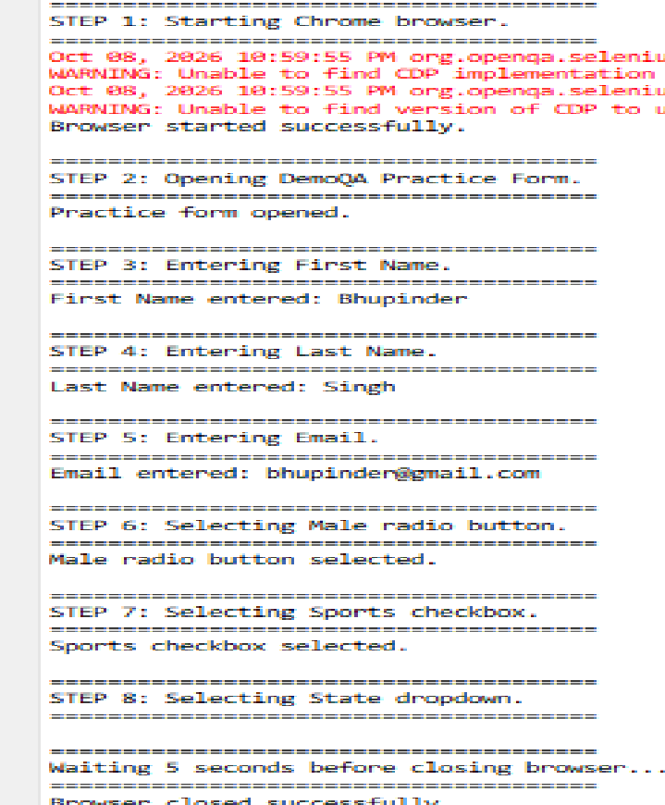
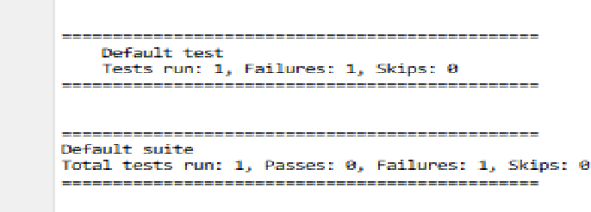

CONCLUSION:
Thus, the Selenium WebDriver practical was successfully performed using Java, Maven, and TestNG. Various web elements such as text boxes, radio buttons, checkboxes, dropdowns, alerts, and frames were successfully identified and interacted with. Implicit and explicit waits were also implemented to handle synchronization between the WebDriver and web page elements. Hence, the practical helped in understanding web element interaction and synchronizati

Practical 10
Aim: Load testing using appache Jmeter_

Design and execute load testing scenarios for web applications and analyse response time.
- Software Required
- Apache JMeter
- Java JDK
- Web browser
- Internet connection

PROCEDURE
- Download and install Apache JMeter.
  - Open JMeter and create a new Test Plan.
  - Add a Thread Group to the Test Plan.
  - Configure the number of virtual users, ramp-up period, and loop count.
  - Add an HTTP Request sampler and enter the target server name and path.
  - Add a Listener, such as View Results Tree or Summary Report.
  - Run the test plan.
  - Analyse the response time, throughput, and error rate from the results. Expected Output
The JMeter results display the following performance metrics:
    - Sample Time: Time taken to receive a response.
    - Average Response Time: Average time taken to process requests.
    - Throughput: Number of requests processed per unit of time.
    - Error Percentage: Percentage of failed requests.
    - Min/Max Response Time: Minimum and maximum response times recorded.
Note: Actual response times and error percentages depend on the target server and network conditions.

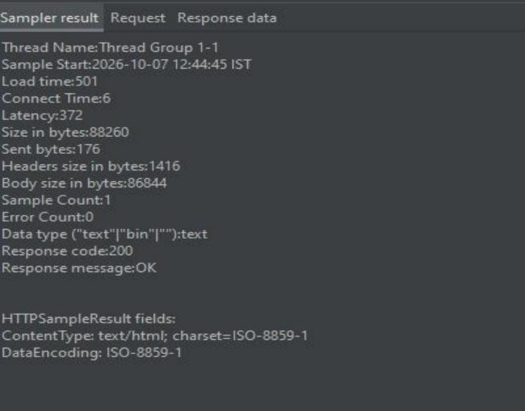
Result:-

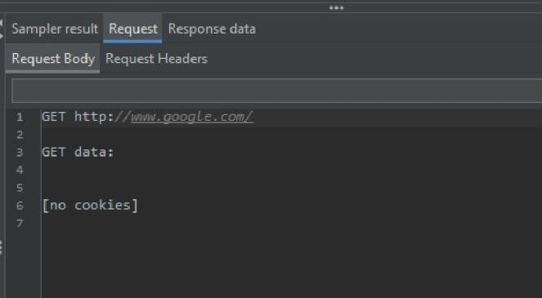
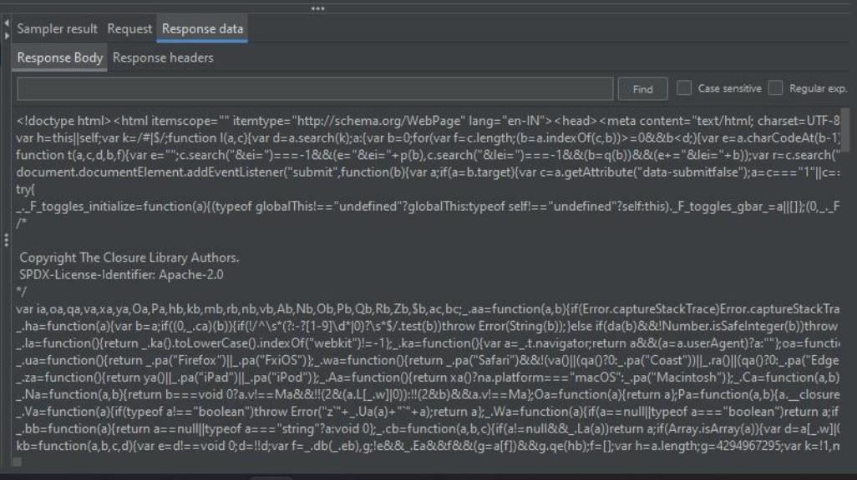
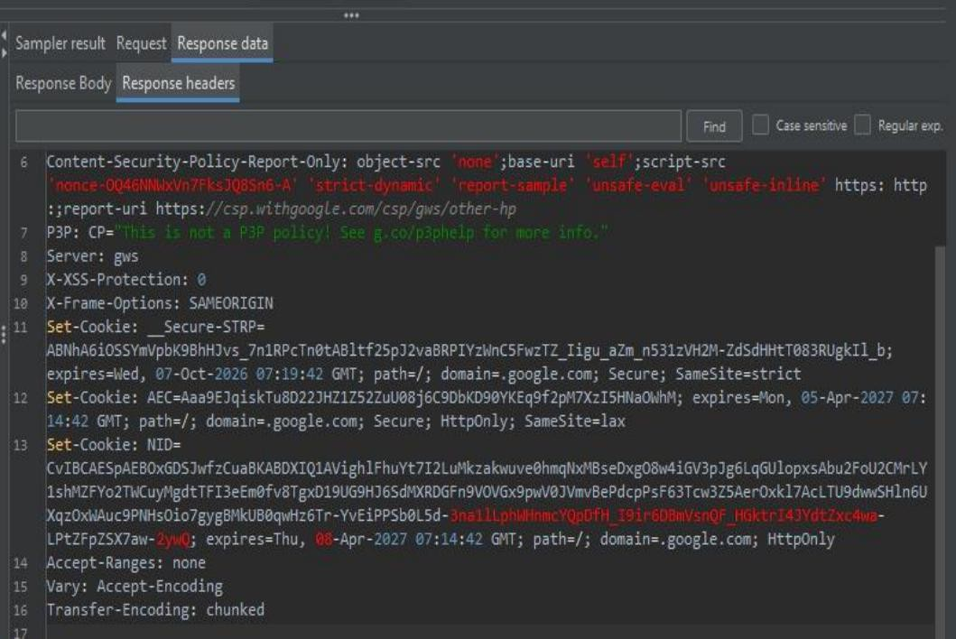

CONCLUSION:
Load testing using Apache JMeter was performed to simulate multiple users accessing a web application. The response time, throughput, and error percentage were analysed to evaluate the application's performance under load.
Apache JMeter is an open-source testing tool used to perform load testing, performance testing, and stress testing of web applications. It simulates multiple virtual users accessing an application simultaneously and measures performance metrics such as response time, throughput, and error percentage.

